**NAME: KASONGO NATHAN KALONJI**

**REG. NO: S20B23/003**

**Question One**

1. Define a statement of work and outline the work products of your course project.

* A statement of work (SOW) is a document that provides a description of a given project's requirements.
* Work products include surveys, presentations, reports, design.

II. Elaborate 5 potential risks likely to threaten your project and how to they can be mitigated.

* High costs. The expected budget might be exceeded due to inflation world-wide. To mitigate cost risk, estimate each element of your project accurately and stick closely to your budget. The best way to stick to your budget is to create a project plan.
* Time. More time will be needed to accomplish the project successfully. To mitigate this, an extra member will need to be added on the group so as to finish in time.
* Stretched resources. The best way to mitigate resource risk is to create a resource allocation plan.
* Lack of clarity. It may come in the form of miscommunication from unmeet deadlines etc. By keeping information in a central tool, you can ensure everyone stays updated as the project progresses.

III. Explain the five stages of your project.

1. **Project initiation:**

Initiation is the formal start of a project. We usually begin with the issue of a project mandate which briefly describes the purpose of the project and authorizes budget spend.

1. **Project planning:**

At this stage, I also defined the project scope, and developed a project plan and work breakdown schedule.

1. **Project execution:**

During this phase, I followed my project plan and started to work on the tasks and activities to produce the project deliverables.

1. **Project monitoring and control:**

They require measuring project progression and performance, and dealing with any issues that arise from day-to-day work.

1. **Project close:**

During this last phase, the project is completed and a testing is conducted before reviewing.

IV. Is your project objective driven or product driven, elaborate on the difference.

* Objective driven.
* In Product Driven Projects, the base problem is identified and only has to develop a previously determined or designed product while In object driven projects the main objective of the final outcome is considered.

**Question Two**

1. Explain the Agile Methods

Agile methodology is referred to as step by step dynamic focused on short-term visibility but never losing the long-term product goal.

1. **Crystal:**

Crystal is one of the most flexible frameworks, giving more freedom to the team to develop their own processes. It focuses way more on individuals and how they interact rather than on the process or the tools so communication is an essential key aspect.

1. **Lean Development:**

This method offers a conceptual framework and follows values, principles and good development practices that can be applied to an Agile development for example Lean development forces the team to remove any activity that does not bring ultimate value to the product.

1. **Extreme Programming:**

Extreme Programming methodology is based around the idea of discovering “the simplest thing that will work” without putting too much weight on the long-term product view.

1. **Scrum:**

It is characterized by cycles or stages of development, known as sprints.

1. Draw a product break down structure for your project

Display

Micro-controller

ADC

Alcohol Sensor & Amplifier

Buzzer

Ignition Key

Relay for Vehicle control

Max232 Serial Interface

DC Motor

1. Draw the product flow diagram and the derived activity network

* The product flow diagram is a representation of the order by which a sequence of products is created according to product-based planning principles.

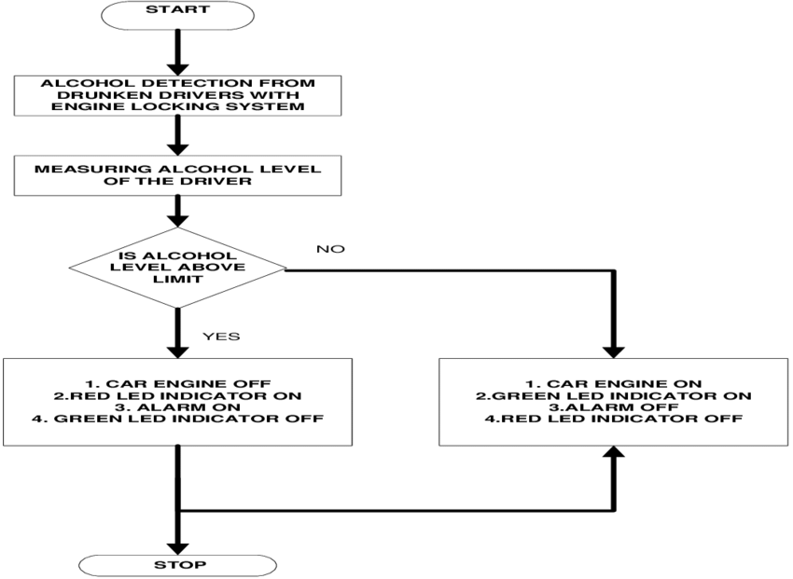

**Question Three**

Define the different types of contracts in software projects

1. **Fixed Price:**

It means the project has clear documentation, a defined project scope, terms and conditions, and, of course, a deadline. For this contract type, the technology we’ll use is fast and thus we can deliver your project fast. However, the very nature of the project implies that all the requirements are given at the beginning of it, so there is not much flexibility here.

1. **Time & Material Software Development Contract:**

This is a pricing model that calculates and charges the time spent by each specialist of the software development team. However, this approach to work requires close attention to detail within the software development agreement drafting.

If your project is between 1 and 2 months, there is no clear vision of its functionality, you are open to altering your requirements if more beneficial ideas are suggested and your project has a flexible budget then T&M contract is exactly what you need.

1. **Dedicated Team:**

This is an outsourcing business model that allows clients to hire a remote software development team under their management. It works best when the company needs to obtain professional developers for a long-term project.

**REFERENCES**

1. <https://fulcrum.rocks/blog/software-development-contract>
2. <https://www.wrike.com/project-management-guide/faq/what-is-a-statement-of-work-in-project-management/>